Effects of normalization with vector fields

Circular repulsive vector field of radius 0.01 with no component normalization or decay function. Vectors increase in length as they diverge from the intersection of surfaces.

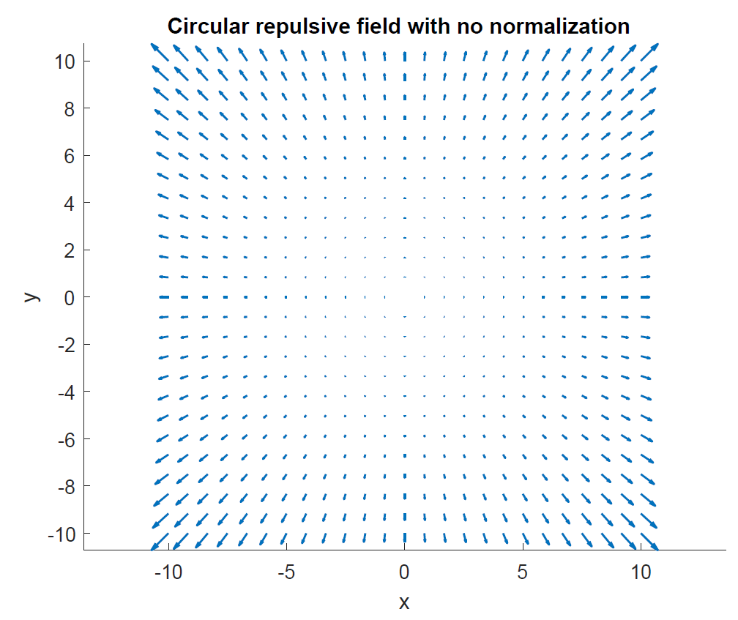

Normalizing the U and V components results in equal length vectors throughout the sampled spaced. This is necessary to ensure predictable decay function application which is accomplished with the tangent hyperbolic function next.

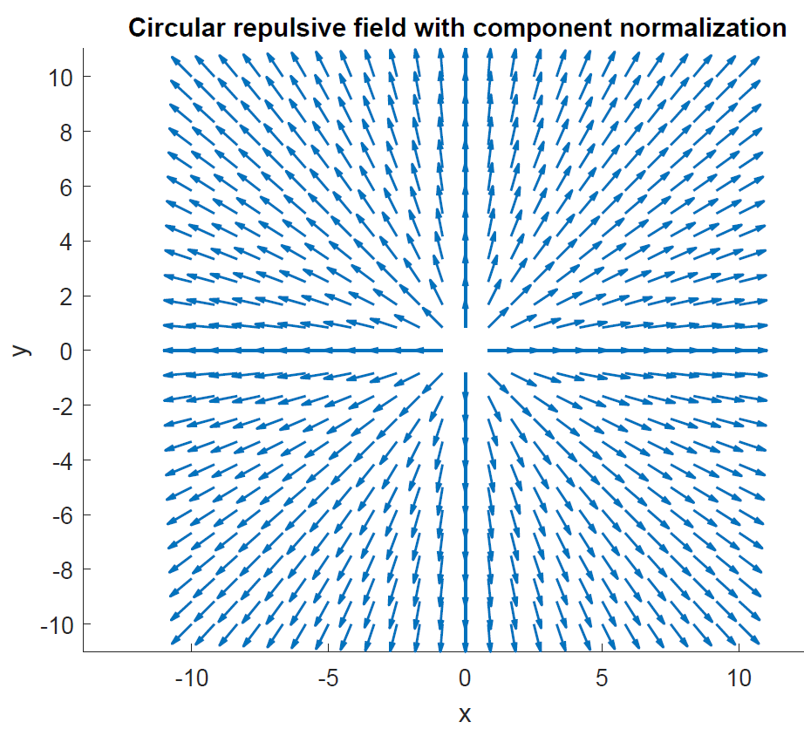

The tangent hyperbolic decay function provides a weight on the interval (0,2).

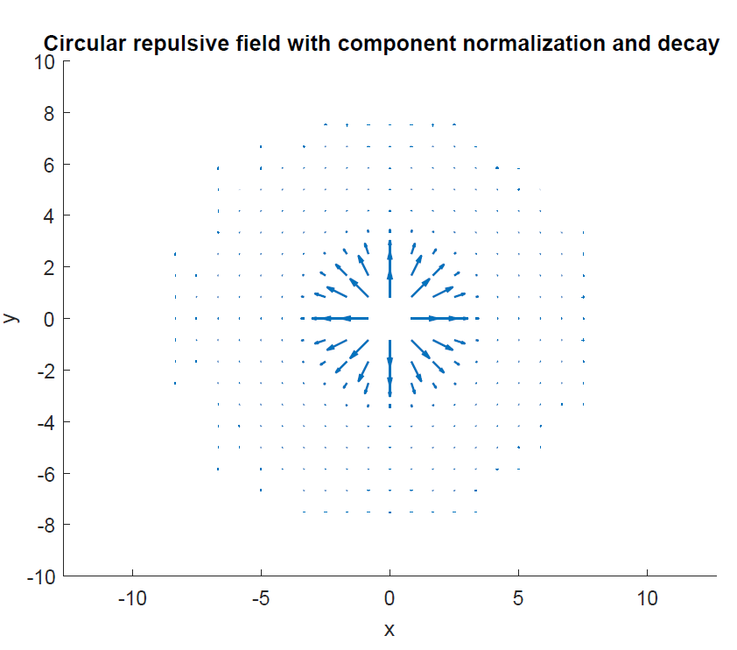

Vector field for straight path following is shown with no normalization below. Vectors farther away point more towards the path. Vectors in close proximity to the path flow along the path.

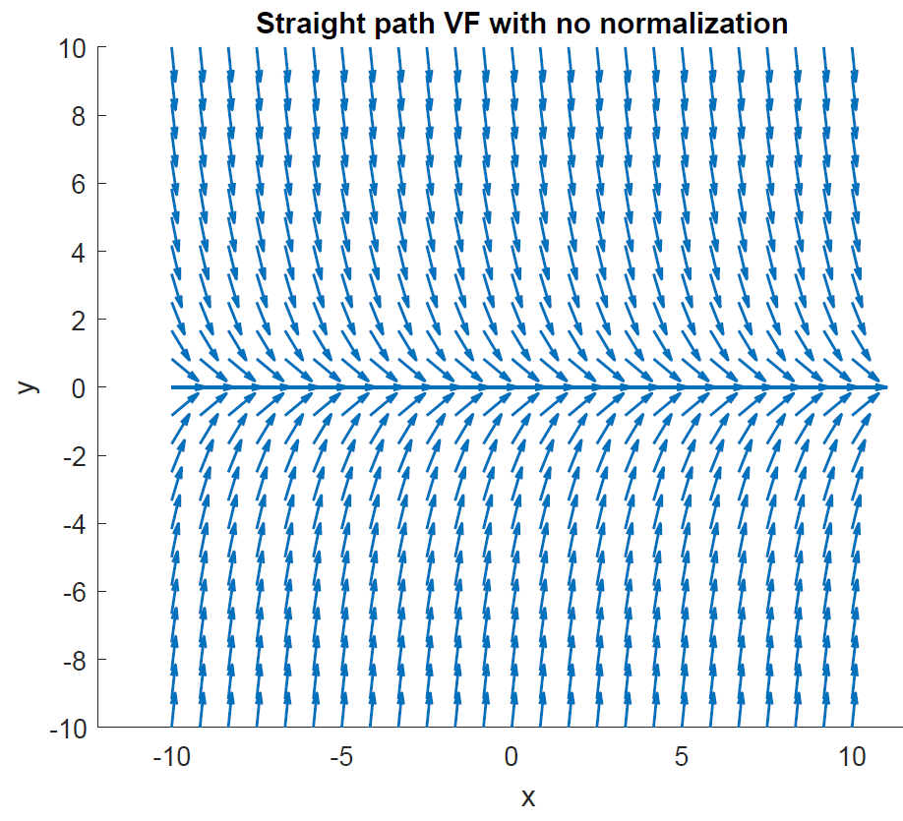

Normalizing the VF components results in a more uniform field that appears to have equal convergent and circulation behavior.

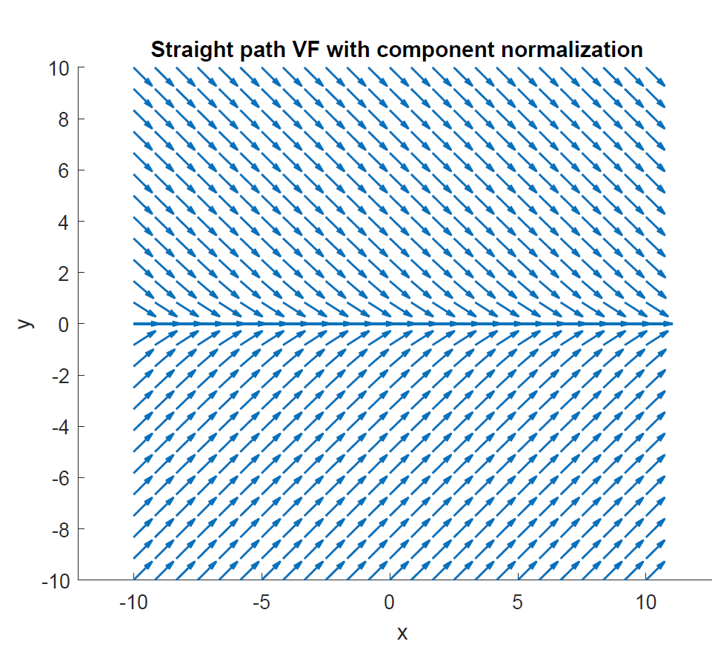

Summing a non normalized goal field with a non normalized repulsive field with a tan hyperbolic decay function produces the following guidance. Note how outside the decay region the attractive field strength is significantly less than that of the obstacle. That is due to two factors:

1. Repulsive vectors are not normalized, therefore can be >1 in length
2. Repulsive vectors are then multiplied by the decay function p(range) which may increase the magnitude by as much as 2x the repulsive vectors original strength.

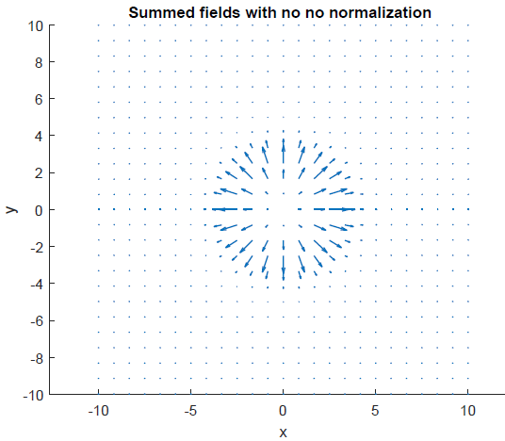

Normalizing the repulsive field limits the strength of the repulsive guidance and allows the goal guidance to contribute to the sum.

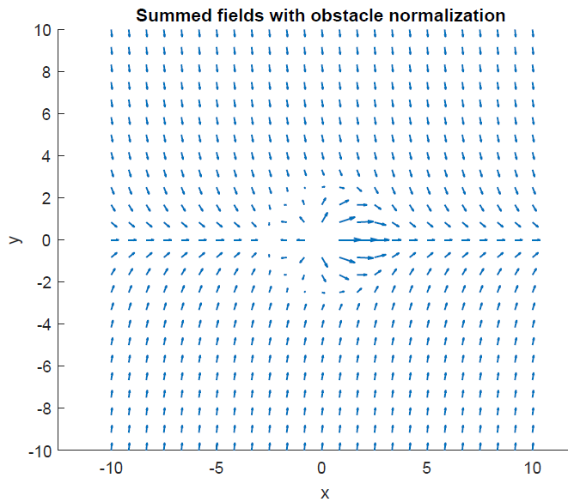

Normalizing both repulsive and goal fields results in the following guidance:

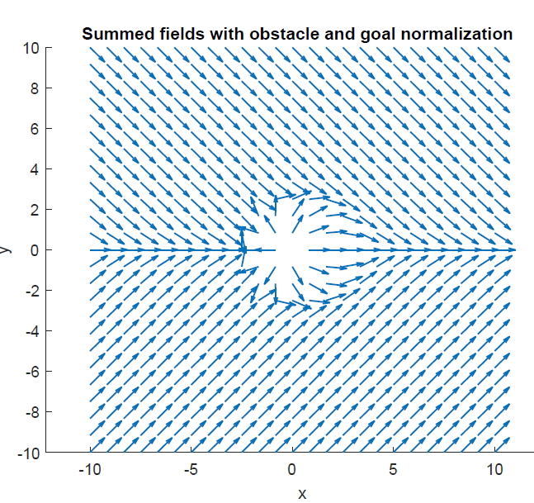

Conclusions on each level of normalization:

* Obstacle component normalization is required prior to applying the decay function. Normalizing prior gives all vectors and equal contribution and the decay function dictates the strength
* Normalization on the straight path vector field appears to have no impact on the length of the vectors
* Normalizing the obstacle and goal AFTER being summed together provide a convenient visualization of the field and provides a bounded input to the heading controller

For determining the location of singularities it will be necessary to look at the gradient of magnitudes prior to the final normalization.

